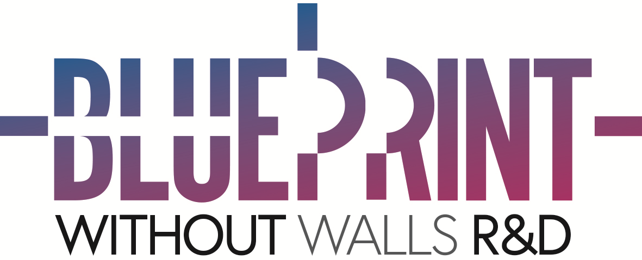

Without Walls Blueprint investment 2021 – Application form template

Please ensure you read the guidance notes before submitting a proposal.

This document has been created to enable you to prepare your proposal offline. All proposals are to be made through the online portal at www.withoutwalls.uk.com/open-calls

- Application details
  - Artist/Company
  - Name of Lead Contact person for this proposal
- Pronouns  (optional – delete as appropriate) | he/him/his/his/himself  she/her/her/hers/herself  they/them/their/theirs/themselves  ze/hir/hir/hirs/hirself  ze/zim/zir/zirs/zirself  Other:
  - Position
  - Address
City
County
Postcode
- Region / Nation of applicant:  (delete as appropriate) | London / Midlands / North / South East / South West  Wales / Scotland / Northern Ireland
  - Phone Number
  - Email address
  - Website
- Does the Lead Contact person for this application have any access requirements?  (If so please specify) | Yes [ ]  No [ ]

- Project Synopsis
2.1. Project Title
2.2. Summary of proposal (200 characters max, including spaces)
2.3. Please indicate the main art-form that best describes your project: | Aerial / Circus / Clown / Dance / Dance Theatre / Digital  Installation / Music / Sound / Physical Theatre / Puppetry  Street Theatre / Theatre / Walkabout / *Other
2.4 Please list any other art forms that you wish to explore in the work | Aerial / Circus / Clown / Dance / Dance Theatre / Digital  Installation / Music / Sound / Physical Theatre / Puppetry  Street Theatre / Theatre / Walkabout / *Other
*You selected 'other' above, please explain here
2.5. About the following questions:
Without Walls will consider a project to be ‘led by’ a particular group if the majority of key creative team members identify as belonging to that group. This means that some projects may be able to answer ‘Yes’ in more than one category.
Is your project:  (Please select all that apply.) | Black, Asian, ethnically diverse-led: Yes / No  Deaf or Disabled-led: Yes / No  Female-led: Yes / No  LGBTQIAP- led: Yes / No
2.6. Does your project fit in to any of these categories?  (Please select all that apply.) | Digital: Yes / No  Large Scale: Yes / No  Children & Young People: Yes / No  N/A
2.7. When will your R&D process take place? (Please see the guidance notes regarding timelines)
2.8. Are you requesting creation space support from Without Walls? | Yes / No
2.9. If so, how many days/weeks access to creation space would you require?
2.10. Please describe the type and size of space you require, and any special conditions (We ask that you be as upfront and clear as possible about your requirements and to include any known access requires for company members that you will be working with.).

- DESCRIPTION OF YOUR WORK

3.1. Please describe your proposal or project (4000 characters including spaces):

3.2. Please explain what you plan to achieve through your R&D and how it will contribute to the overall development of your project (2000 characters including spaces):

3.3. If applicable, please summarise how you intend to use this process to explore new areas or practices with your work. This is not imperative but we are keen to encourage artists to try new things and explore their creative process at a deeper level. (2000 characters including spaces)

3.4. Please describe your company / artists / collaborators and indicate whether you have created outdoor work before (3000 characters including spaces)

3.5. Are you planning to offer a sharing of your work as you develop it (either in person or online)?
If so when would this occur during the R&D? We recognise difficulties in bringing people together in a physical location so therefore are happy for the online sharing of work. (2000 characters including spaces)

3.6. Are you planning to embed sustainable models of practice as part of the creation and touring of the piece (not solely about the content or subject matter)? If so please describe here:

3.7. Following on from a successful R&D, when would you be looking to premiere the piece

2022 [ ]
2023 [ ]

- Budget & Finance
4.1. How much money are you requesting from Without Walls for this R&D? | £
4.2. If known, please give an indication of the approximate cost for completion of the full project. | £
4.3. Please upload a budget for your R&D project
It is not essential that you have other investors in the project but if you do please indicate these in the budget. Please specify if your additional income is confirmed or expected.
4.4. Are you VAT registered? Yes No

4.5. Are there any other forms of support that could be beneficial for the development of your project. This could be, for example, mentoring, producer support or dramaturgical support. If your proposal is successful, this will be discussed with you in more detail.

5. Support information & material

5.1. Marketing Material

You do not have to send any support material with your online proposal but if you do please only send us three images of no more than 3MB each. Clearly mark your supporting material document with your Company Name and the words “Without Walls Blueprint support material”

Attached [ ]

5.2. File sharing link (OneDrive, WeTransfer, Dropbox link, etc):
If you have any supporting material to share with us that exceeds the 3MB allowance, then please share a link to this here:

5.3. Vimeo / YouTube links:

6. Consent

I consent to and understand the value of the sharing of my proposal with the artistic directorate and any additional partners as required, to support Without Walls with the selection process. Yes/No.

References
You do not have to supply a reference with this proposal, but if you want you can include a letter of support from a promoter or other professional contact. This would be especially useful if you are an artist or company new to the UK outdoor arts scene.

Deadline

Please upload your information to the online portal at www.withoutwalls.uk.com/open-calls by 17.00 on

Friday 8th January 2021.

Artists will be informed whether their proposal will be supported by the end of March 2021.

